JOBS for LIFE: GRADUATION!
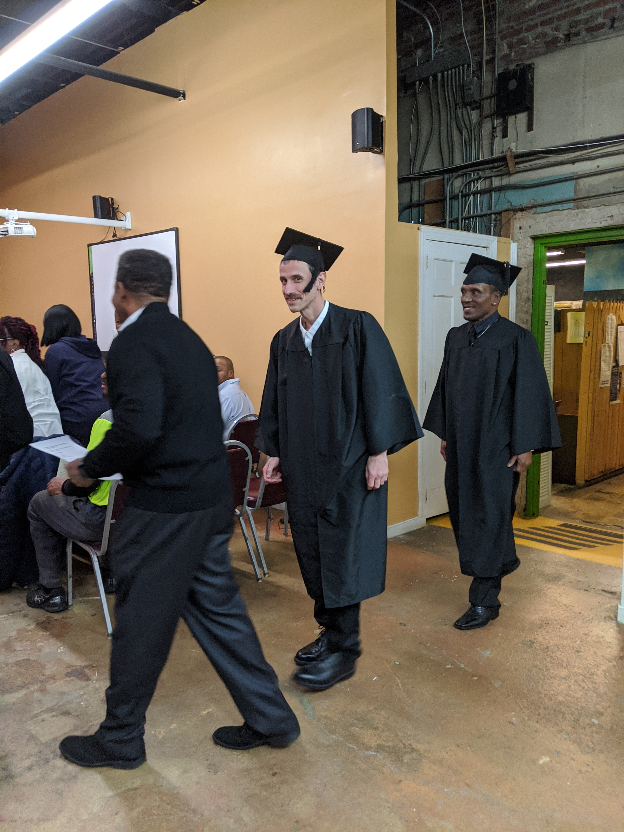
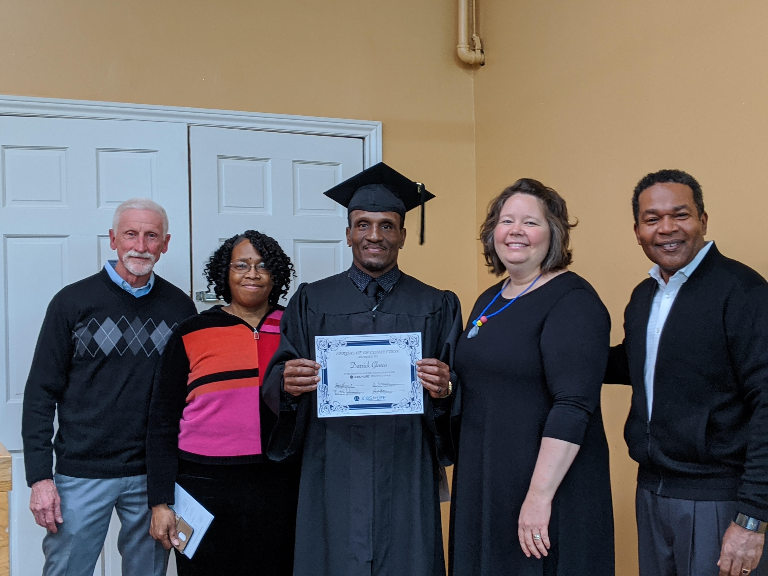
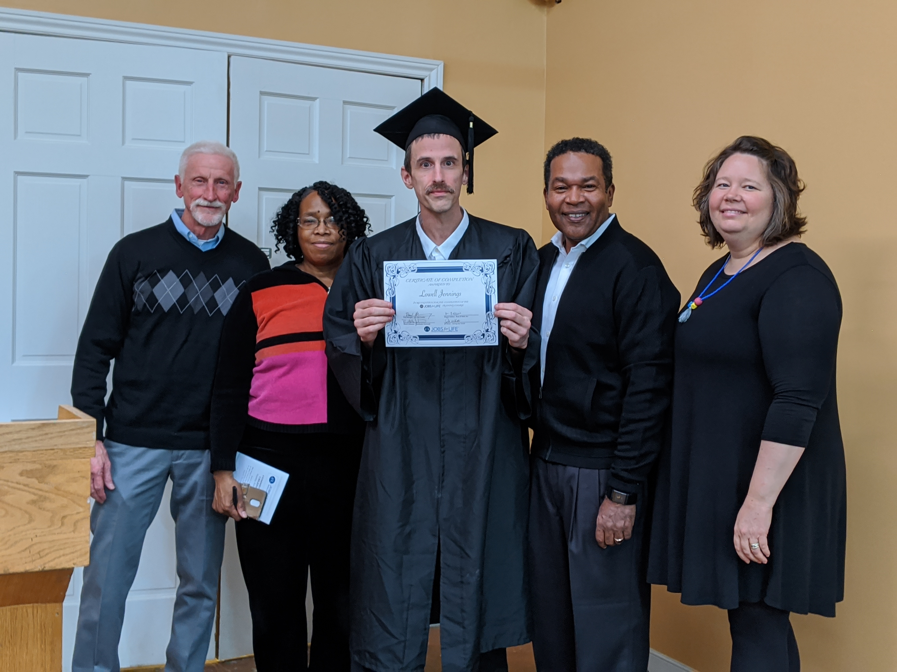

March 2020 Edition

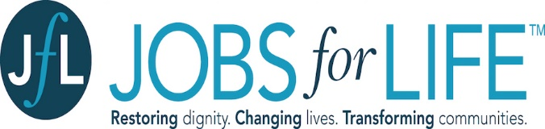

JOBS for LIFE is a job readiness training and support program that uniquely empowers participants to be successful in work and life. The first Class of 2020 graduated [month ##^{th}]! We are excited to support free JOBS for LIFE through partnership with Boaz & Ruth and the Northside Outreach Center. [can we list their names here?] Classes cover topics including:
- Communication Exercises
- Career Assessments
- Individual Reflections
- Workplace Role-Playing
- Professional Resumé
- How to Apply for Jobs

With our new partnership with Communities in Schools (CIS), we are now able to reach the students better. Through this partnership, we are now visiting John Marshall High once a month to meet with students and we can also post our activities on their school activity boards!

SPECIAL ANNOUNCEMENT: In February, we set up three youth with one on one mentorship. Our volunteer mentors serve as Higher Education and Career Coordinators, in addition to providing social support. Our fourth volunteer mentor is coming on board now. Potential mentors undergo a background check and training to help them be a positive mentor for our exceptional youth.

We applied to the Mayor’s Office to participate in the Mayor’s Youth Academy; last year, we enrolled five youth in this summer program which will run from mid July to the end of August. They will gain first-hand experience on projects to help prepare them for the future. Our students learn effective communication skills, resume writing, interviewing techniques, conflict resolution, professionalism, and other essential skills. It won’t be all work and no play; the students will have fun opportunities, such as visiting the science museum.

Applications opened March 1st and we’re helping some of our current 6PIC youth on their applications to this exciting program, including the essays. If they get accepted, they could work with us or one of the many other groups that participate in the Mayor’s Youth Academy each year.

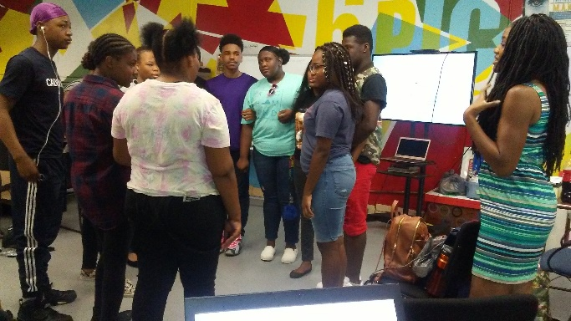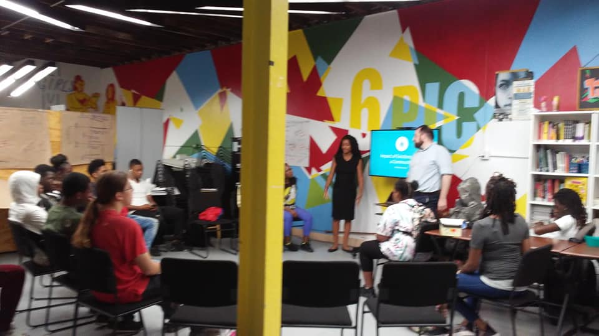
[Type the sidebar content. A sidebar is a standalone supplement to the main document. It is often aligned on the left or right of the page, or located at the top or bottom. Use the Drawing Tools tab to change the formatting of the sidebar text box.
Type the sidebar content. A sidebar is a standalone supplement to the main document. It is often aligned on the left or right of the page, or located at the top or bottom. Use the Drawing Tools tab to change the formatting of the sidebar text box.]
RESURGENCE

A dose of Morality. Right or wrong has a different meaning from what it meant in the 60’s and 70’s. Youth are pushed to do immoral things just to be a part of the crowd and not be singled out. Things that youth are singled out for now are the exact opposite of things we were singled out for. The Resurgence class helps teach our youth that it’s good to be singled out for being the person doing the right thing. That’s what leaders are made of.

These classes are held at St. Giles Presbyterian Church on Wednesday evenings, and led by one of our past Board Members. We’re looking forward to the youth continuing with this class in 2020.

Coming up in April: April 10th – Good Friday Bonfire, April 19th – Donuts and Discussion, April 25th – 26th – Canopy Adventure Park and Overnight Campout.

[Type the sidebar content. A sidebar is a standalone supplement to the main document. It is often aligned on the left or right of the page, or located at the top or bottom. Use the Drawing Tools tab to change the formatting of the sidebar text box.
Type the sidebar content. A sidebar is a standalone supplement to the main document. It is often aligned on the left or right of the page, or located at the top or bottom. Use the Drawing Tools tab to change the formatting of the sidebar text box.]
Please join us in welcoming our new volunteers, Ms. Alice Powell, Mr. Edward Bien Aime and Ms. Whitney Dunn.
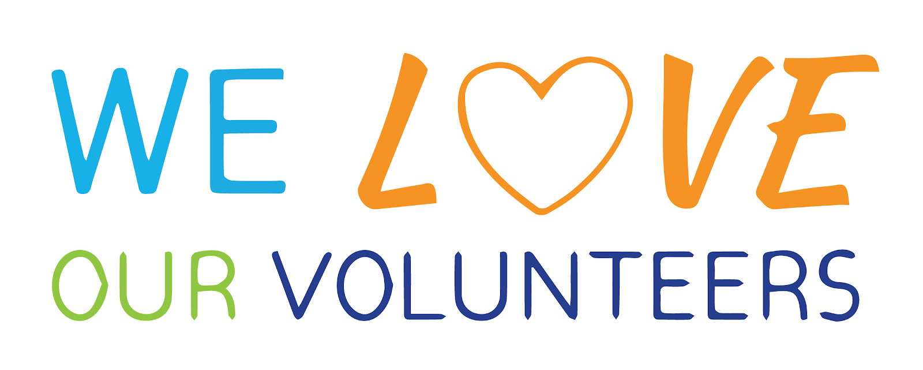

Volunteers generously give their time and dedication. Honestly, things could not run smoothly without the selfless efforts of our volunteers like these. We appreciate all our volunteer and give a heartfelt welcome to our new members.
In recent decades, American society has become very segregated by age – youth attend age-segregated schools, adults rarely spend time with youth in their work environment, and senior citizens often live in housing with only other older adults. On the 1st and 3rd Tuesdays of each month, we’re breaking down many of the physical and social barriers between the generations and provide activities for seniors and youth that offer opportunities for mutually beneficial learning. Some of the activities the seniors and youth have selected include making a quilt that will hang in the community area, feeding the homeless, and sharing Christmas events. This program started in November 2019 and is running well.
Adopt a Senior
[Type the sidebar content. A sidebar is a standalone supplement to the main document. It is often aligned on the left or right of the page, or located at the top or bottom. Use the Drawing Tools tab to change the formatting of the sidebar text box.
Type the sidebar content. A sidebar is a standalone supplement to the main document. It is often aligned on the left or right of the page, or located at the top or bottom. Use the Drawing Tools tab to change the formatting of the sidebar text box.]

This 2020 program has just started. We’re working with 5 youth in collaboration with Advocacy for Richmond Youth and Change the World RVA, both advocates for youth who experience housing instability. The youth we worked with had all experienced issues with homelessness.

One of the best tools to help break the chain of poverty in families is for them to understand what the chains are made of and collect the appropriate tools to do the job. Although the youth experience homelessness because they are with parents who experience homelessness, now is the time to teach them how to break that cycle so they don’t repeat it as adults.
[Type the sidebar content. A sidebar is a standalone supplement to the main document. It is often aligned on the left or right of the page, or located at the top or bottom. Use the Drawing Tools tab to change the formatting of the sidebar text box.
Type the sidebar content. A sidebar is a standalone supplement to the main document. It is often aligned on the left or right of the page, or located at the top or bottom. Use the Drawing Tools tab to change the formatting of the sidebar text box.]
This message is for everyone but especially for our youth in college or trade school, those who recently graduated from college/trade school or from high school, and for those recently entering the job market. Be Extraordinary! The difference between someone being ordinary and extraordinary is extra. Don’t just be ordinary, be Extra – Ordinary! What does it take to be Extraordinary you ask….
Messages from the
Executive Director

Extraordinary people become successful people. You have to take the time to be successful, you can’t sleep your time away. Don’t sleep away your blessings. You won’t have to use an alarm clock to wake you up, your passion will wake you up.

Extraordinary/successful people are not necessarily people make money. You can make a lot of money and still not a accomplish a thing. Don’t use your money to purchase a $45,000 car to impress people, you don’t need designer clothes to impressive, and PLEASE DO NOT pluck money into alcohol and drugs.

There’s so much more but I’ve run out of space so, do good, live well, and prosper.

Jo White
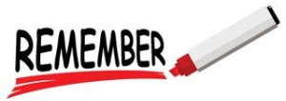

Please remember us in your charitable giving.
Your donations are tax deductible.

A child raised in 23222 is more likely to be raised in poverty, to live in a household where one or more adults is unemployed, and to attend a school where indicators show many students are lagging behind on literacy, attendance, and graduation. For just $25 per month, just 83 cents per day, you can give a youth with these circumstances a better chance for a better future.

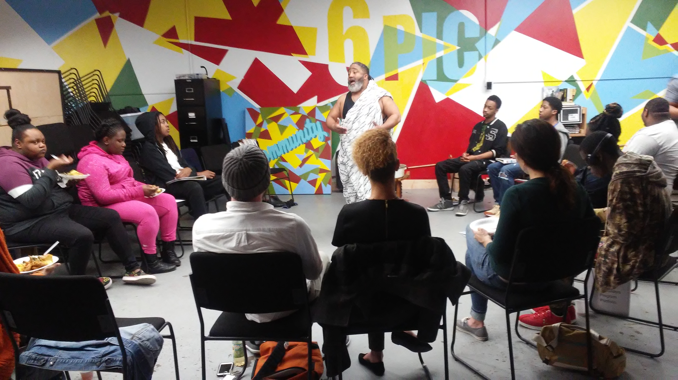
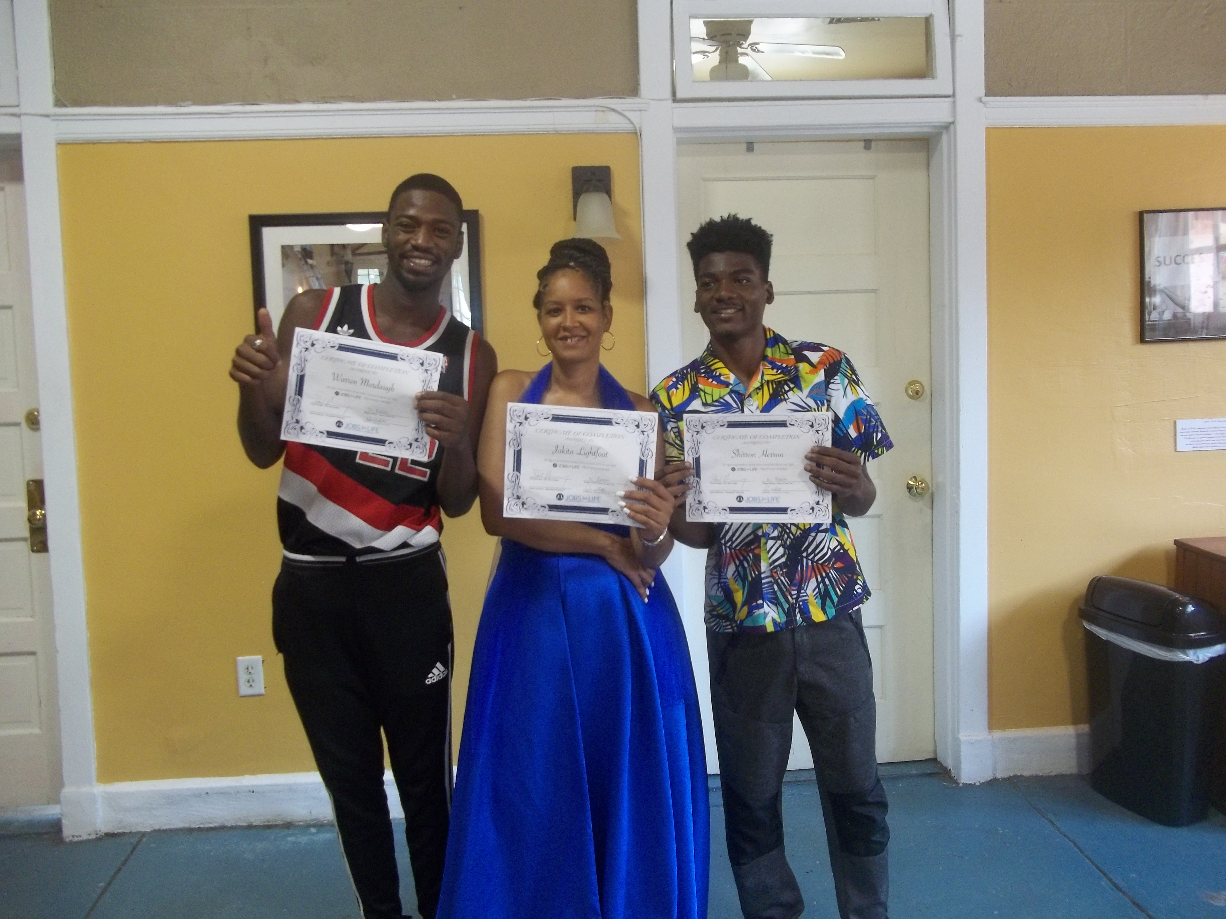
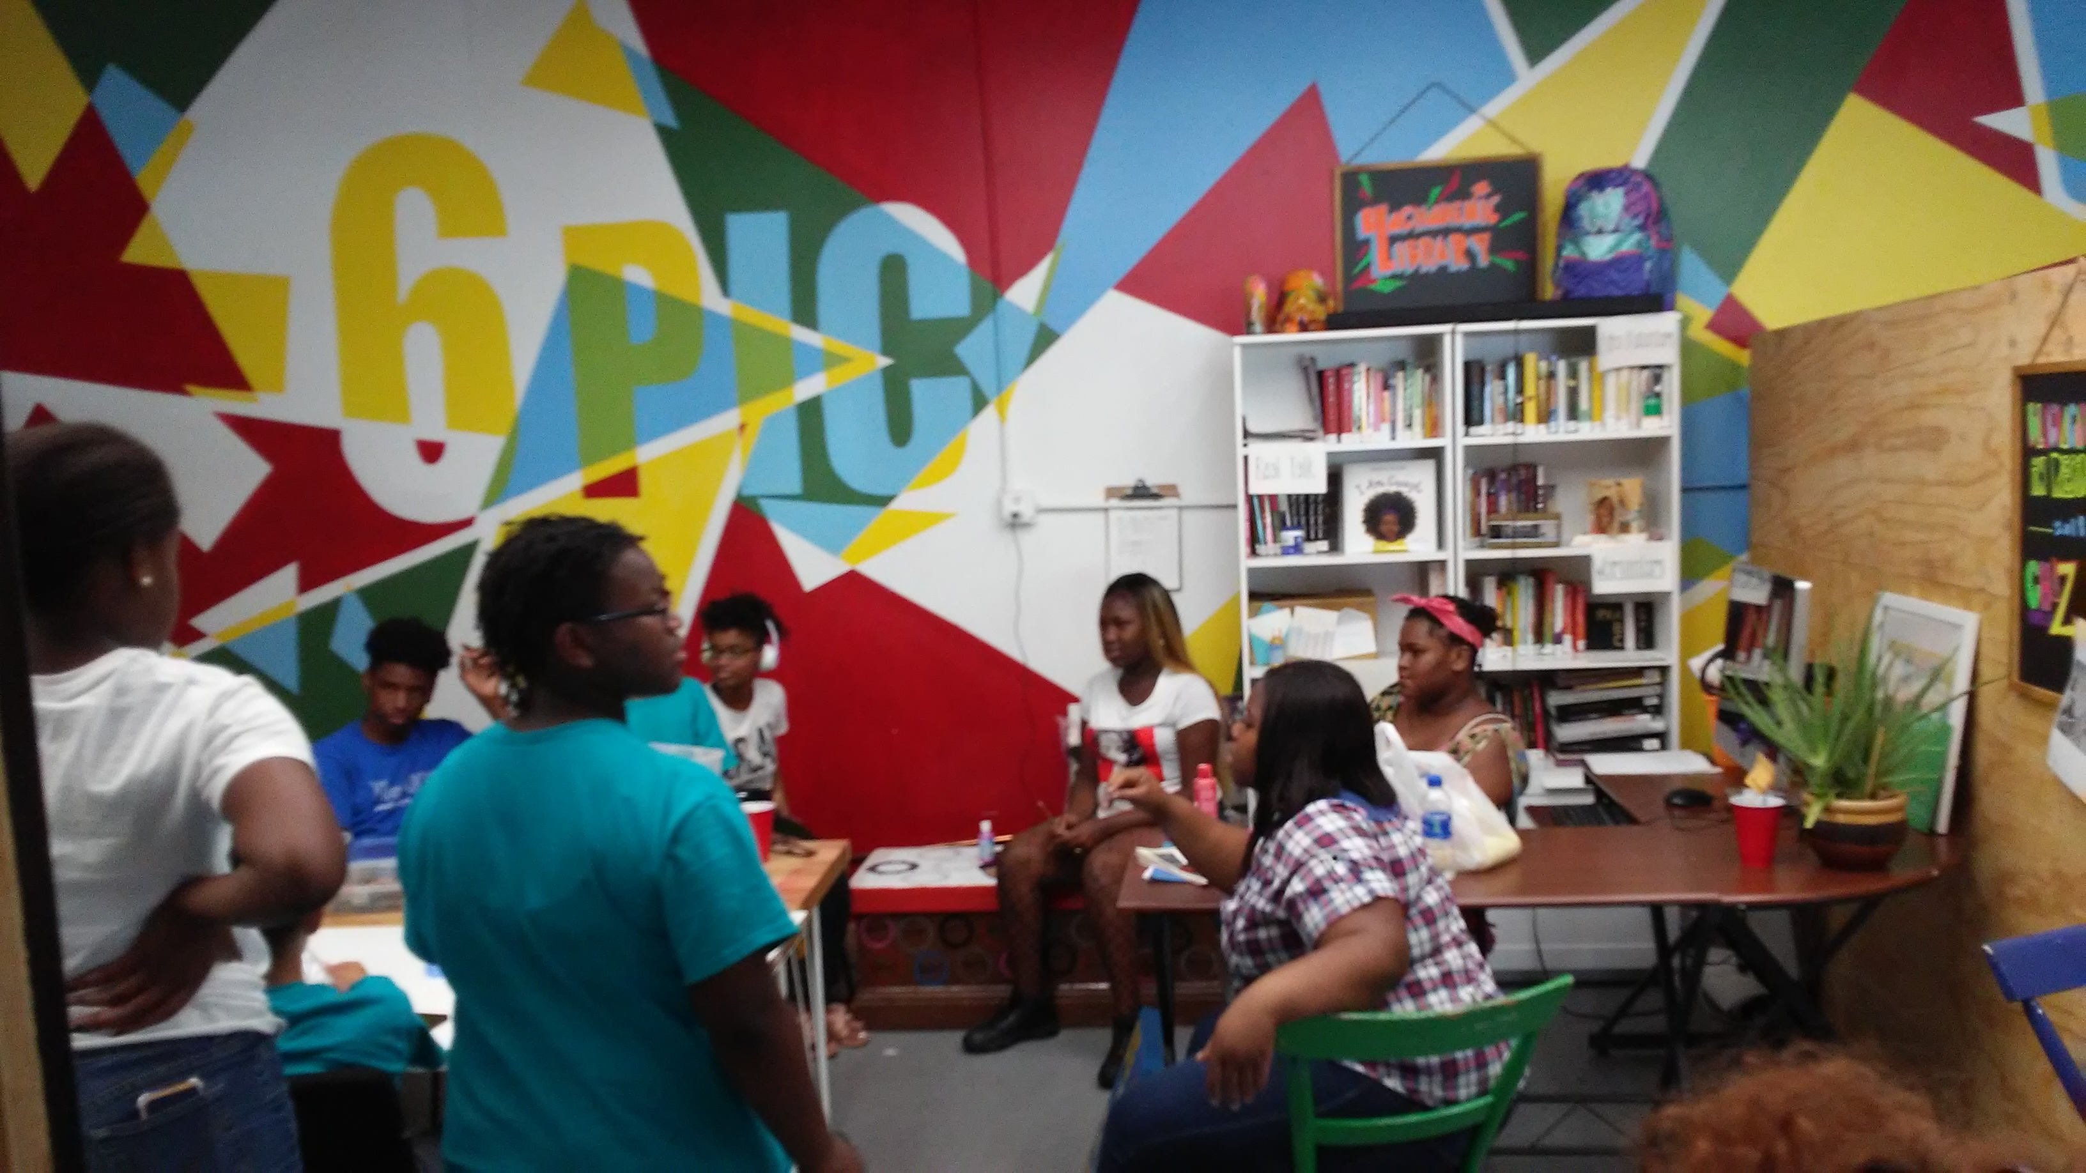

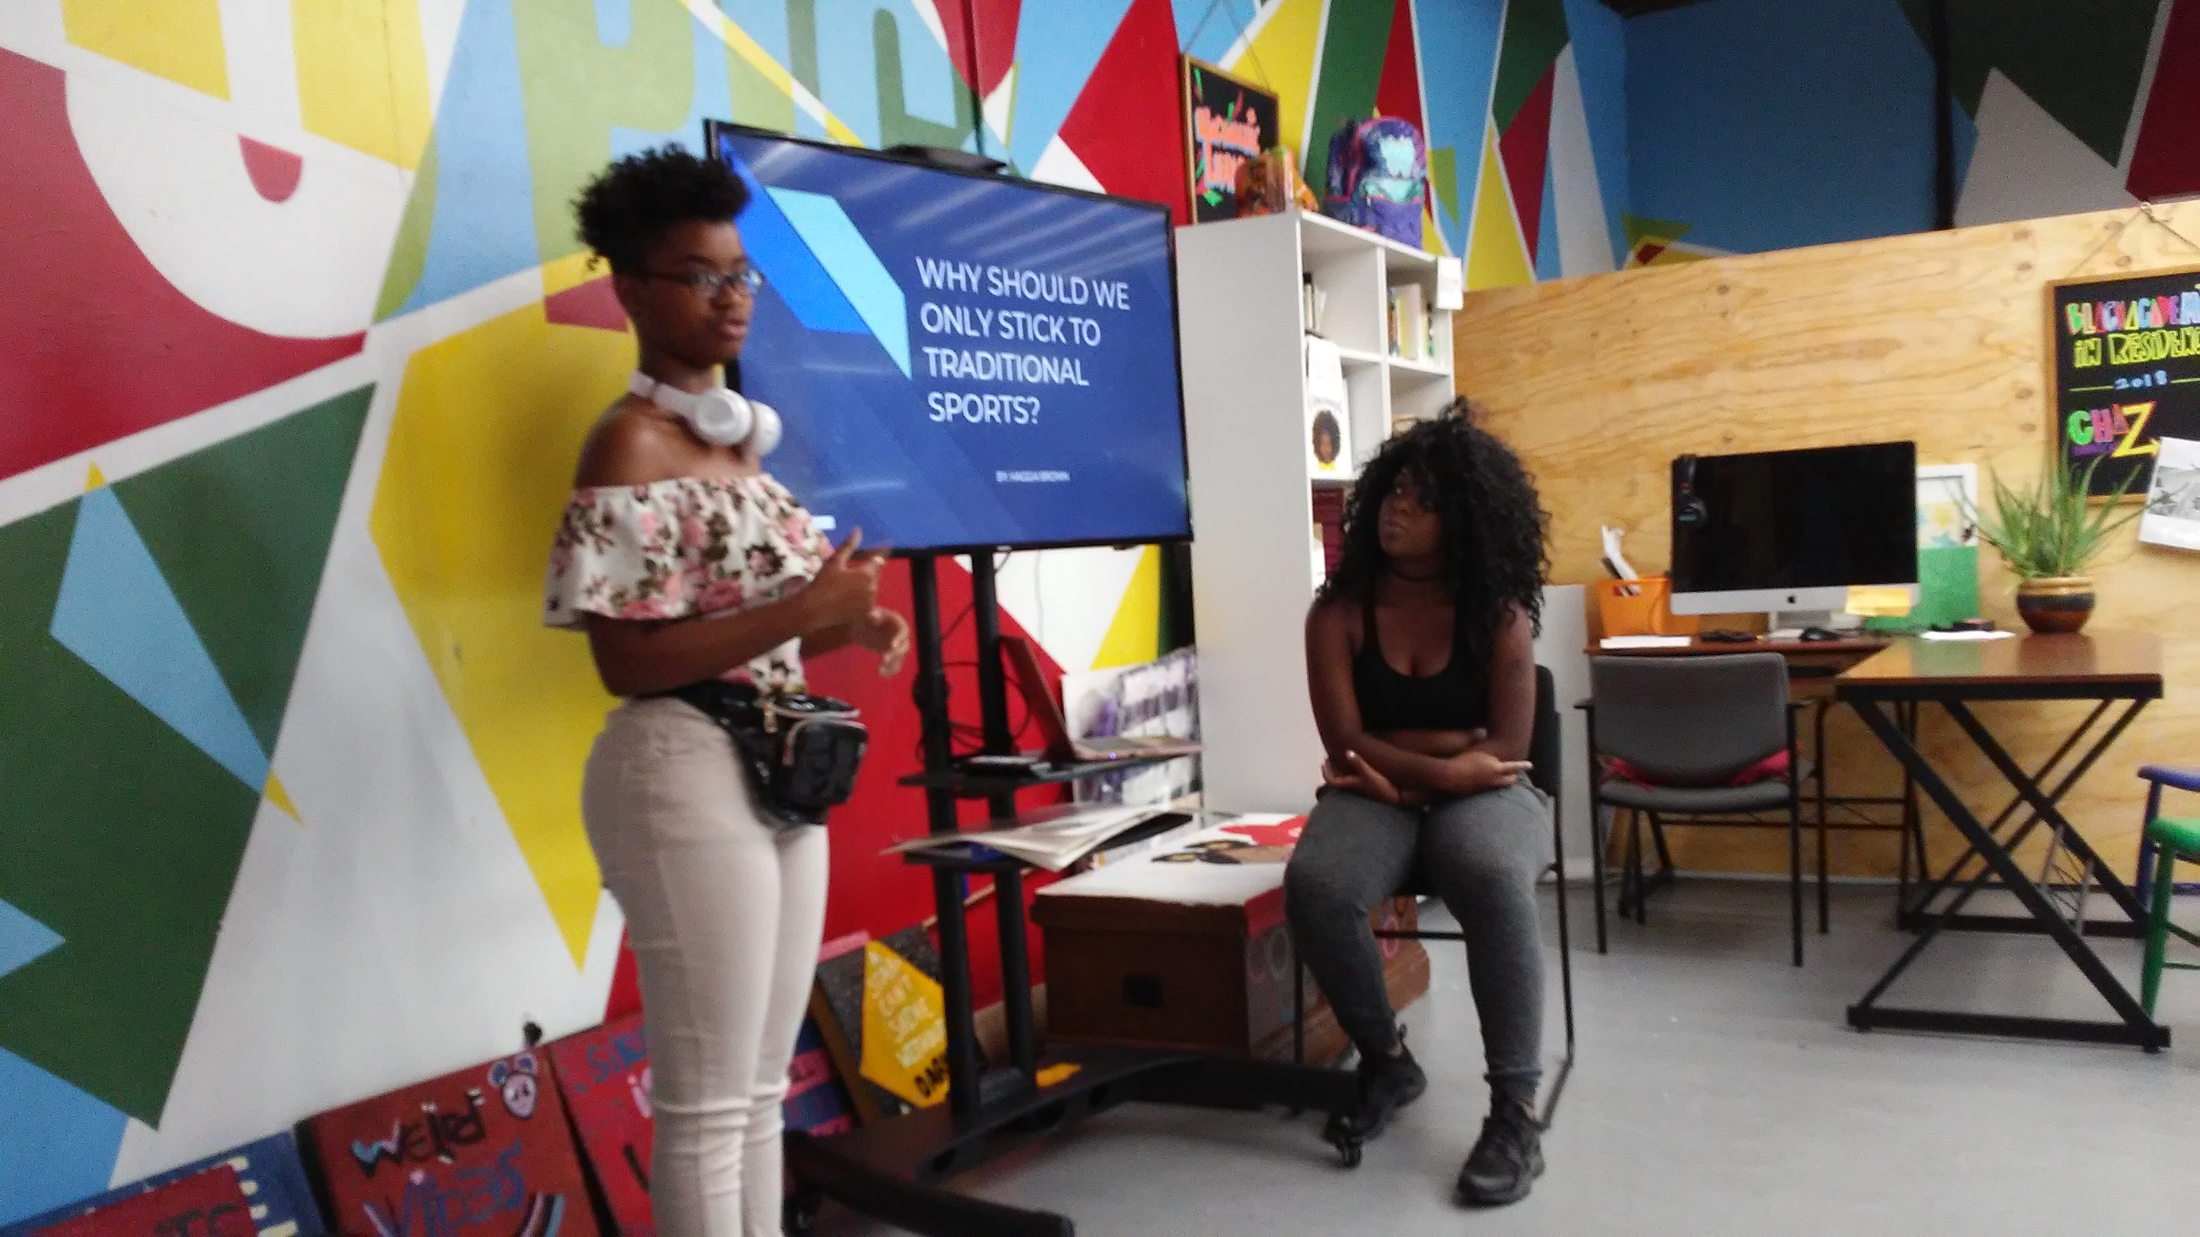
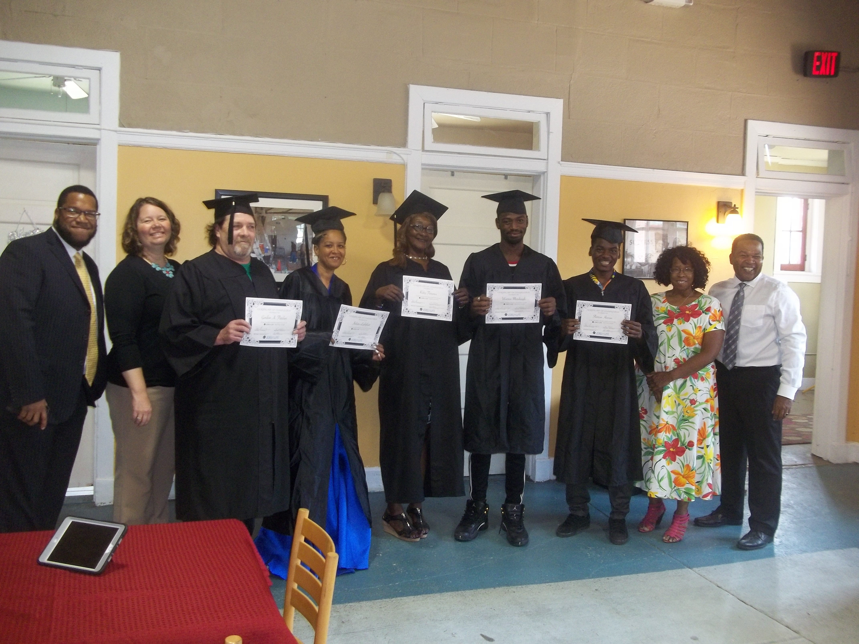
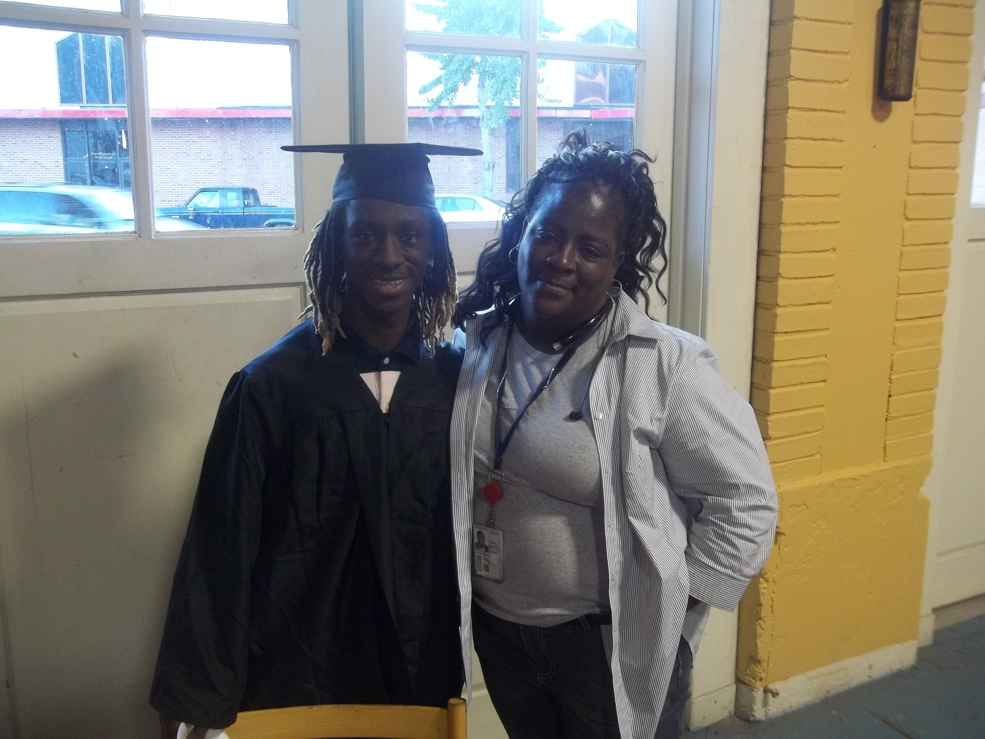

Also, please visit us at Six Points Innovation Center where we are part of the 6PIC collaborative to see firsthand how your donations help to serve the community.

Saving Our Youth VA
3001 Meadowbridge Rd.
Richmond, VA 23222
(804) 321-2789 Office
(804) 937-6836 Executive Director Cell

